Project Design Phase-II
Technology Stack (Architecture & Stack)
Date | 14 July 2026
Team ID | SWTID-2026-5258
Project Name | India's Agricultural Crop Production Analysis (1997–2021)
Maximum Marks | 4 Marks

Technical Architecture:
The Agricultural Crop Production Dashboard follows a simple linear flow: the user opens the dashboard through a web browser, the Tableau Public dashboard fetches data from the Excel dataset, the processing engine cleans and aggregates the data, and the resulting visualizations give the user insights that support their farming or policy decisions.
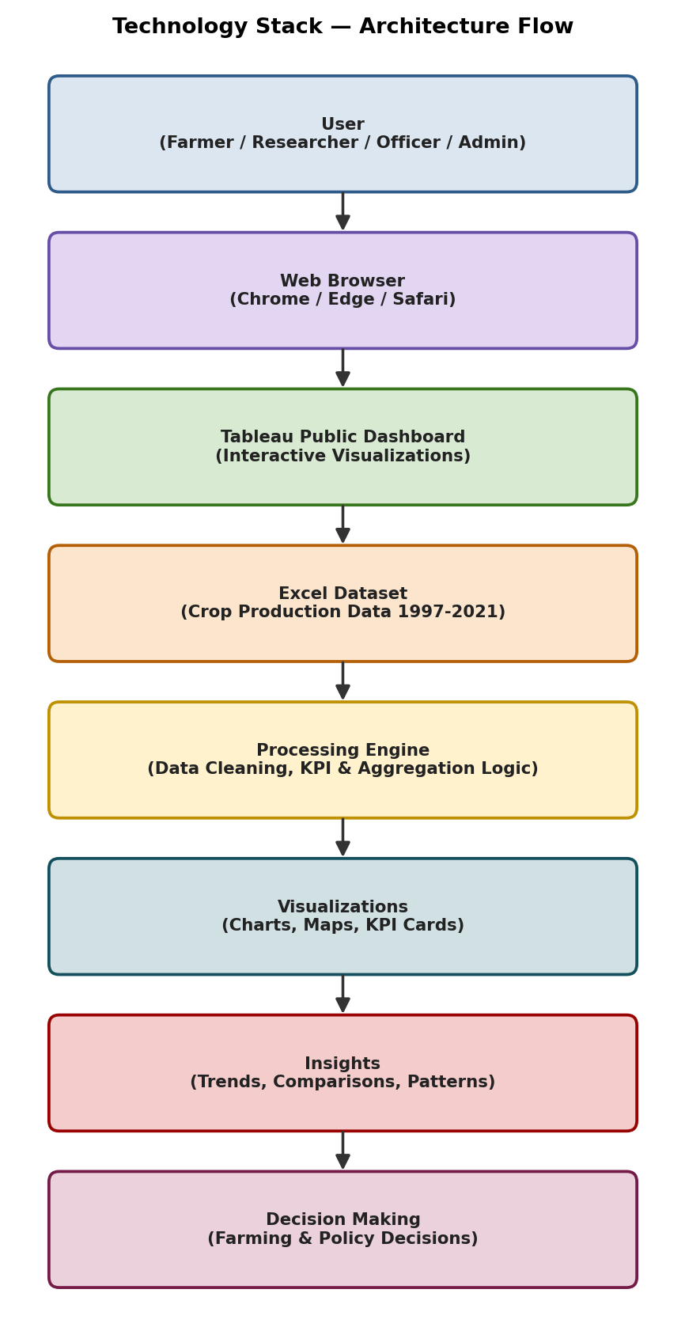

Table-1 : Components & Technologies:

S.No | Component | Description | Technology
1. | User Interface | How the farmer, researcher, or officer interacts with the dashboard through their browser. | Tableau Public Dashboard (Web UI), HTML/CSS rendered by Tableau
2. | Application Logic-1 | Logic for connecting the dashboard to the underlying crop production dataset. | Tableau Data Source Connection (Excel connector)
3. | Application Logic-2 | Logic for filtering data by state, crop, year, and season. | Tableau Filters, Parameters, Calculated Fields
4. | Application Logic-3 | Logic for computing KPI values such as Total Production and Total Yield. | Tableau Calculated Fields, Aggregations (SUM, AVG)
5. | Visualization Engine | Renders charts, maps, and KPI cards from the processed data. | Tableau Public (Maps, Bar Charts, Line Charts, KPI Cards)
6. | Database | Stores the structured crop production data used by the dashboard. | Excel Workbook (.xlsx) with State, District, Crop, Season, Area, Production, Yield, Year fields
7. | File Storage | Stores the source Excel dataset and exported reports. | Local Filesystem / Google Drive (shared storage)
8. | External API-1 | Not used in the current version; may be added later for weather correlation. | Not Applicable (planned: Weather API)
9. | Machine Learning Model | Not used in the current version; dashboard focuses on descriptive analytics. | Not Applicable
10. | Infrastructure (Server / Cloud) | The dashboard is published and hosted on Tableau Public's cloud servers so it can be accessed from any browser. Local Server Configuration: Not required (development done on local machine with Tableau Desktop). Cloud Server Configuration: Tableau Public Cloud (hosted by Tableau/Salesforce). | Tableau Public Cloud, Tableau Desktop (development)

Table-2: Application Characteristics:

S.No | Characteristics | Description | Technology
1. | Open-Source Frameworks | The dashboard uses Tableau Public's visualization engine along with Excel for data preparation; no custom code frameworks are required. | Tableau Public, Microsoft Excel
2. | Security | Dataset editing is restricted to the administrator; the published dashboard is view-only for other users, and the link is shared only with intended users. | Tableau Public View-Only Publish, Restricted Excel Editing Access
3. | Scalable Architecture | The single dashboard design can absorb new years, states, or crops simply by refreshing the Excel data source, without rebuilding the charts. | Tableau Public Extract Refresh
4. | Availability | Tableau Public hosts the dashboard on its own reliable cloud infrastructure, so it stays available without the team managing servers. | Tableau Public Cloud Hosting
5. | Performance | KPI cards and charts are pre-aggregated using Tableau's in-memory data engine so that filter changes update the view within a few seconds. | Tableau Hyper Engine, In-Memory Extracts

References:
https://public.tableau.com/
https://help.tableau.com/current/pro/desktop/en-us/help.htm
https://www.data.gov.in/

